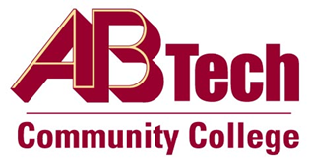

# Asheville-Buncombe Technical Community College (A-B Tech) Policy Manual

## Policy 310: Campus Sex Crimes Prevention Act Compliance

It is the policy of the Board of Trustees of Asheville-Buncombe Technical Community College to maintain compliance with the Campus Sex Crimes Prevention Act of 2000 by providing a link to the North Carolina Sex Offender and Public Protection Registry.

## Scope

All College employees, volunteers, interns and visitors.

## Definitions

Sex Offender: Generic term for all persons convicted of crimes involving sex, including rape, molestation, sexual harassment and pornography production or distribution.

North Carolina Law requires sex offenders who have been convicted of certain offenses to register with their county sheriff. Information about offenders is entered into the Registry database by the sheriff’s office and transmitted to the N.C. State Bureau of Investigation.

### References

The North Carolina State Bureau of Investigation makes this information available via the Sex Offender and Public Protection Registry website. The website for North Carolina and websites for other state registries are below:

1. [FBI Safety Registry](https://www.fbi.gov/scams-and-safety/sex-offender-registry)
2. [National Sex Offender Public Registry](https://www.nsopw.gov/)
3. [NC Sex Offender and Public Protection Registry](http://ncdoj.gov/Protect-Yourself/Find-Sex-Offenders/SexOffenderRegPrograms.aspx)

Reviewed by the Executive Leadership Team, November 29, 2012

Attorney Review, December 3, 2012

## Policy Owner

Vice President of Operations/CIO, Ext. 7900

Approved by the Board of Trustees on January 28, 2013.